**High Altitude Muon Detection**

J. Fender, J. Morris, and J. Ringler

Faculty Advisor: M. Semak

*Department of Physics and Astronomy, University of Northern Colorado, Greeley, CO 80639* April 11, 2017

Abstract

We are pursuing a method for the detection of cosmic ray muons as a function of altitude. The detector will be a part of a self-contained autonomous payload that is carried up to altitude aboard a weather balloon. The payload will contain a plastic scintillator coupled with a silicon photomultiplier and two Geiger counters. All three will be connected to a coincidence circuit, making up the muon detection system. This system, along with various other sensors including an internal temperature sensor and altimeter, will be controlled by an onboard Arduino Mega microcontroller. So far, we have only constructed the portion of the payload that utilizes the Geiger counters, the coincidence circuit, and the Arduino Mega. These components were tested during the most recent high altitude balloon flight. During this flight, several malfunctions occurred including an electrical error that caused the payload to shut down 30 minutes into the flight. Even with these faults, the data that was collected is still consistent with that of previous flights and the expected results.

1

1. *Introduction*

**Muons**

From 1911-1913, the experiments performed by Victor Hess led to the discovery of cosmic rays, for which he received the Nobel Prize in 1936 [1]. Originally thought to be some form of electromagnetic radiation, it was later revealed that cosmic rays are almost exclusively high-energy charged particles that originate outside of **Earth’s atmosphere** and bombard the planet from all directions in space [2]. Though the sun is a source of some of these cosmic rays, **it’s believed that** most of these particles originate in mechanisms such as those observed in thecenter of active galactic nuclei, as well as in the catastrophic events following supernovae [3]. Cosmic rays are composed of particles in similar proportion to that found throughout the galaxy. Approximately 89% of the particles that make up the rays are hydrogen nuclei, protons, 10% are helium nuclei, and 1% are nuclei from heavier elements [4].

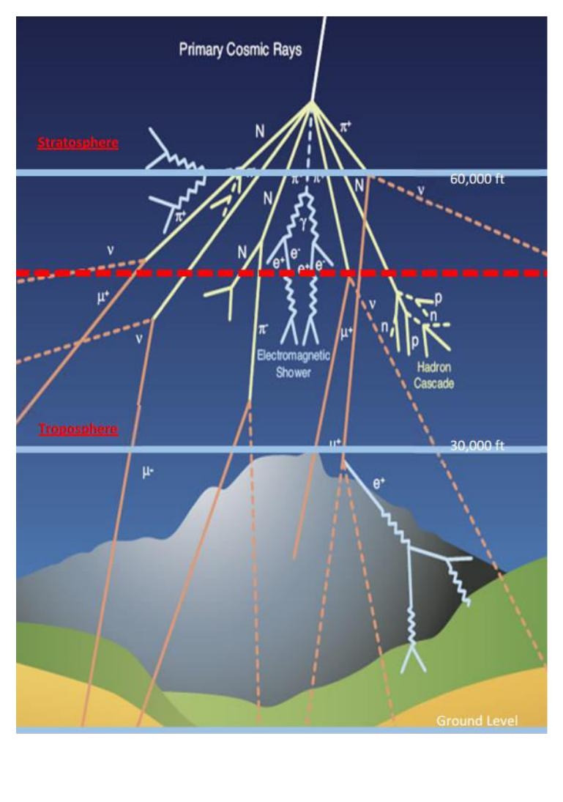

When very high energy cosmic rays enter **Earth’s atmosphere**, they interact and collide with atmospheric particles, through which large **“**showers**”** of secondary particles are generated [5]. These collisions occur primarily in the stratosphere, which is **a layer of the Earth’s** atmosphere that extends radially from approximately 9 to 31 miles above the **planet’s surface [**6]. The predominantmechanism through which atmospheric ionizing radiation is produced is the collision between cosmic rays and atmospheric molecules. As the cosmic rays penetrate more deeply into **Earth’s** atmosphere, the increasing density of molecules in the atmosphere greatly increases the probability of additional

*Figure 1. A diagram showing a cosmic shower*

*Source: https://wipac.wisc.edu/deco/project*

2

collisions. These later collisions then cause product particles to disperse and create larger showers [see Figure 1].

When these showers occur, most products are pions which decay rapidly and subsequently form even larger showers of muons, neutrinos, and gamma rays [7]. Of these particles, the muon is **most likely to reach the planet’s surface before decaying** into other particles. The muon travels at large speeds approaching that of light, which means that relativistic effects on its trajectory are significant. Given these effects, some of the muons generated in very high altitude collisions can still **reach the Earth’s surface** despite its short lifespan of 2.20 microseconds [8].

**The Palmer Model**

Dr. G. Michael Palmer, a professor at West Virginia University, developed a mathematical model that describes the muon count rate as being proportional to the atmospheric

|  |  |  |  |  |  |  |  |  |  |  |  |  |  |  |  |  |  |  |  |  |  |  |  |  |  |  |
| --- | --- | --- | --- | --- | --- | --- | --- | --- | --- | --- | --- | --- | --- | --- | --- | --- | --- | --- | --- | --- | --- | --- | --- | --- | --- | --- |
| density at a given altitude [9]. The Palmer Function is given below. | | | | | | | | | | | | | | | | | | | |  |  |  |  |  |  |  |
| Where: |  |  |  | **= Φ ∗ ℎ ∗** | | | | | **(− ∗ ℎ −ℎ )** | | | | | | | | | **∗** | **− ∗∫ℎℎ ℎ ℎ** | | | | | | **min−** |  |
| **Φ =** |  |  |  |  |  |  | |  |  |  |  |  | **ℎ** | | **=** | | **,** |  | **,** | **= .** | **counts ft slug −** | | |  |
|  | **=** |  |  |  |  |  |  |  |  |  |  |  |  | **ℎ** | |  |  | **ft** | **ft−** |  |  |
|  | **=** |  |  |  |  |  |  | |  |  |  |  | | **ℎ** |  |  |  |  | **ℎ** |  | **= .** | **ft** | **slug−** |  |  |
| **ℎ** | **=** | **ℎ = ℎ** | | **ℎ = ℎ** | |  | | |  | | |  |  | **ft** | | **=** |  | **,** |  | **slug ft−** |  |  |
|  |  |  |  |  | **ℎ** |  |  |  |  | **ℎ** | | |  | **ℎ** |  |  |  |  |  |
| NASA**’**s Earth Atmosphere Model [10]: | | | | | |  |  |  |  |  |  |  |  |  |  |  |  |  |  |  |  |  |  |  |  |  |
|  |  |  |  | **ℎ =** | | | **(** |  |  | **∗** | |  | **+ .** | | | | | **)** |  |  |  |  |  |  |  |  |
| For *h < 36152 ft*, | |  |  |  |  | **=** | |  | **− .** | | |  |  |  |  | **ℎ** | |  |  |  |  |  |  |  |  |  |
|  |  |  |  |  |  |  |  |  |  |  |  |  |  |  |  |  |  |  |  |  |  |  |  |  |
|  |  |  |  |  | **=** |  |  | **∗ (** | | 3 | **+** | | **. .** | | | | **) .** |  |  |  |  |  |  |  |  |  |

|  |  |  |  |  |  |  |
| --- | --- | --- | --- | --- | --- | --- |
| For *36152 ft < h < 82345 ft*, | **=** | **. ∗= −. −** | | **.** | **ℎ** |  |
|  |  |  |  |  |  |
| For *h > 82345 ft*, | **= −** | **.** | **+ .** |  | **ℎ** |  |
|  |  |  |  |  |  |
|  | **= .** | **∗ (** | **+ .** | **.** | **)− .** |  |

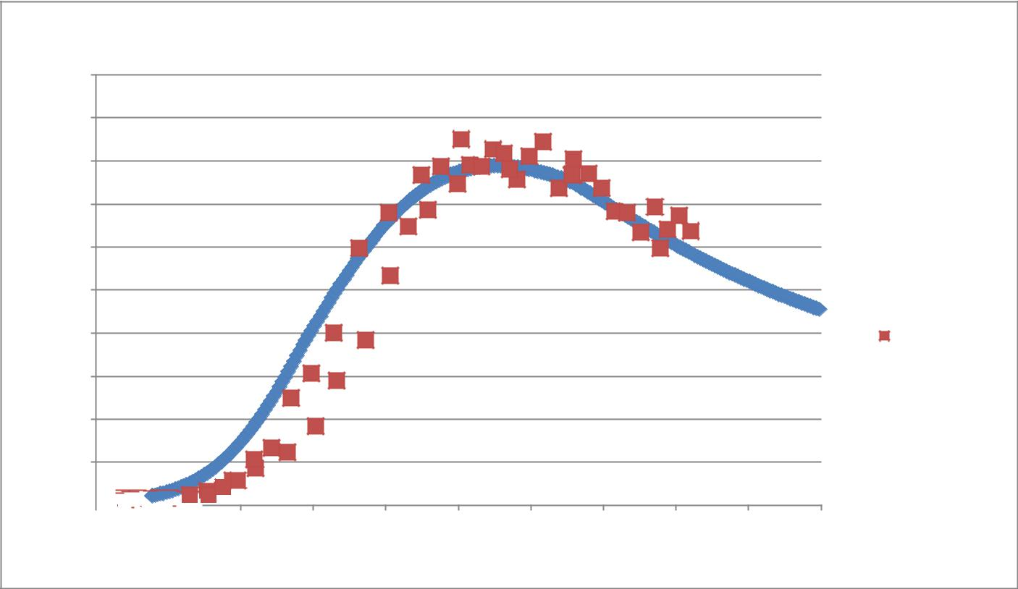

**Palmer Model: Muon Count Rate vs Altitude**

|  |
| --- |
| **Count Rate (cpm)** |

150

135

120

105

90

75

 Palmer Model

|  |  |
| --- | --- |
| 60 | Fall 2016 Data |

45

30

15

0 

0 12500 25000 37500 50000 62500 75000 87500 100000 112500 125000

**Altitude (ft)**

*Figure 2. A graph displaying the data from the Fall 2016 DemoSat launch with the predicted count rate from the Palmer model.*

**Expected Results**

While many of the muons can **reach the Earth’s surface**, a larger portion of them decays before traveling all the way to the ground. Because of this, we expect to see an increase in the muon count rate as the payload increases in altitude. This increase can be seen in the Palmer Model [see Figure 2]. At an altitude between 60,000 and 70,000 feet, we expect to see the count rate reach a maximum. This maximum count rate is known as the Pfotzer Maximum [11]. This

4

threshold is caused by the decrease in the atmospheric density which decreases the likelihood of cosmic rays interacting with an atmospheric molecule.

1. *Materials and Methods*

**Geiger-Müller Tubes**

The primary component of a Geiger counter is the Geiger-Müller tube [see Figure 3]. The operation of Geiger-Müller tubes is based on phenomena observed during the photoelectric effect; that being the ejection of valence electrons in metals due to interactions with incident light [12]. The casing of the tube functions as a cathode, while a thin wire through the center of the tube functions as an anode [13]. The potential difference between the casing and the wire is very large to be able to adequately respond to small charges.

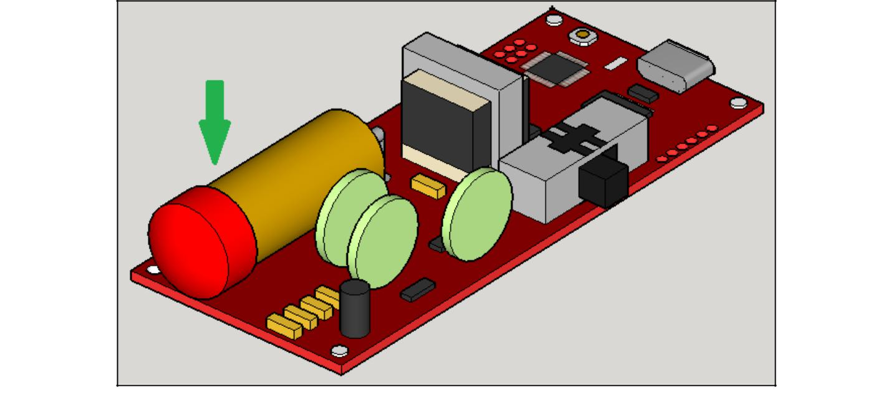

*Figure 3. A 3D rendering of a Geiger counter. The green arrow points to the Geiger-Müller tube.*

The tube is filled with an inert gas to avoid electronic interference between the atoms in **the gas and the device’s anode and** cathode. When high-energy radiation enters the chamber, itionizes the inert gas, releasing an electron with high kinetic energy. The freed electron then collides with other nearby atoms, ionizing them thus freeing additional electrons to participate in further collisions. This free electron cascade is called a Townsend avalanche [see Figure 4]. This **“avalanche” of electrons is then attracted to the** positively charged anode, which simultaneouslyrepels the positive ions of the inert gas. The avalanche is stopped by removing the collected excess electrons, a process known as a Geiger-Müller discharge. This discharge creates a strong electronic pulse to a detector, which then produces a count.

5

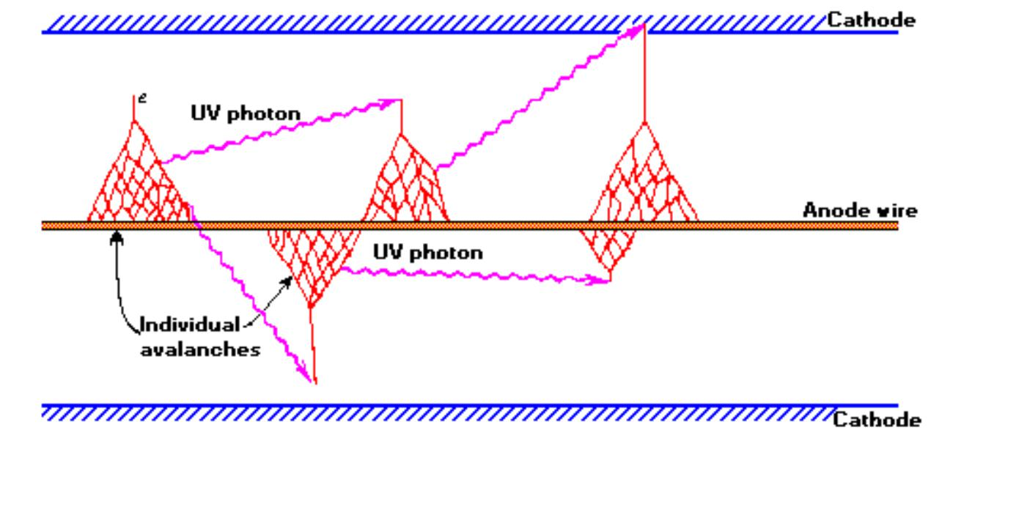

*Figure 4. A diagram of a detection event inside a Geiger-Muller tube. The purple lines are incoming ionizing radiation, and the red web-like lines are the resulting Townsend Avalanches. Their collection on the anode is*

***discharged out of the chamber to be registered as a “count.”***

A major disadvantage of the use of Geiger**–**Müller tubes in the detection of particular particles **is that any charged particle will trigger a “count” on the device. To eliminate as many of** the false counts as possible, thin sheets of lead, 1/8 inch-thick, were added above each of the tubes. The sheets of lead should act as filtering agents by attenuating the radiation caused by particles other than the particle of interest, in this case muons. Muons have much higher energy than other particles and are not as easily deflected by lead.

**Scintillation Detector**

Scintillation detectors come in various forms, but the device used in this experiment will consist of a Silicon Photomultiplier (SiPM) which is attached to the short side face of a Cesium iodide (CI) crystal [see Figure 4]. The SiPM was chosen as the incident detection device due to its small size, allowing for reduction of mass as well as minimizing the needed space inside the payload.

When incident particles enter the CsI crystal, they excite the atoms in the structure and cause them to eject photons. The energy released through these photons is directly proportional to the energy of the incident particle as well as the amount of material the particle has penetrated. This means that the light emitted by each particle detected has a characteristic intensity [14]. The generated light is picked up by the SiPM and converted into an electronic pules. This pules is far to weak for to be detected with the Arduino Mega and is therefore passed through an amplifying circuit first. The amplified signal is then passed through a peak detection circuit. This circuit can

6

be set to only trigger a count when a high enough pules is detected, one that corresponds to the characteristic intensity of the muon passing through the scintillator.

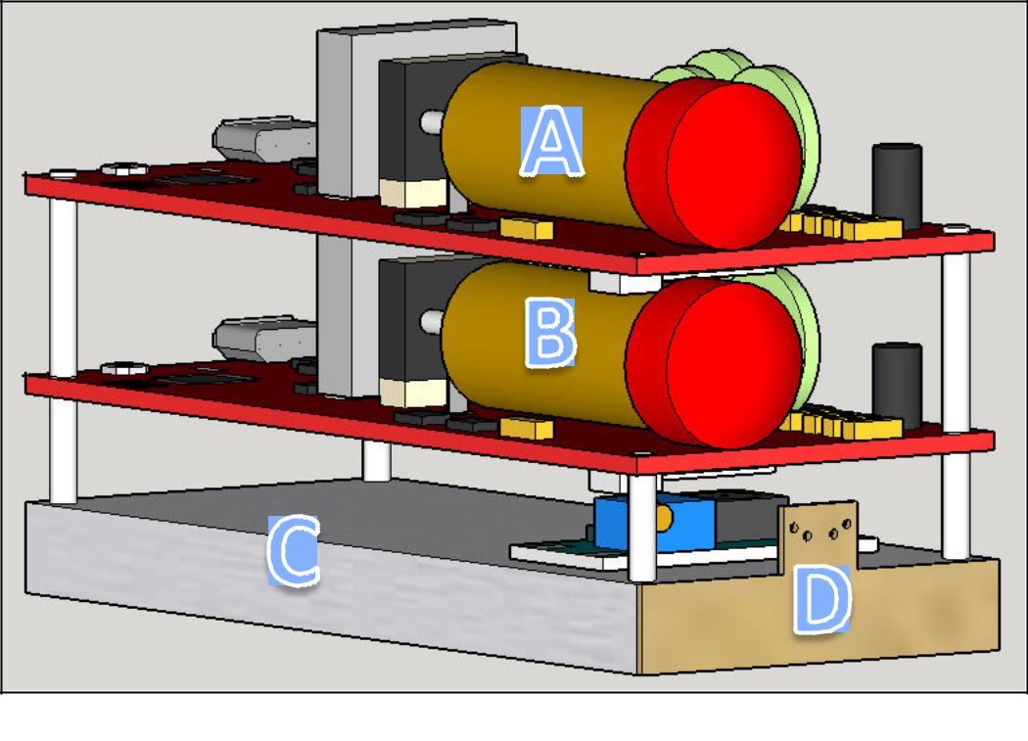

*Figure 4. A 3D rendering of the complete integrated detection device. Objects A and B are the two Geiger-Muller tubes. Object C is the CsI crystal, and object D is the SiPM attached to the short side of the crystal.*

**Coincidence Detection**

Even with the use of lead sheets and the scintillation detector, there is still a possibility for the misidentification of other particles as cosmic ray muons. As a further method to filter out as much of the noise as possible, a coincidence detection circuit is used. A coincidence detection circuit will only register a count when at least two of the detectors are triggered virtually

**simultaneously. For this payload, the coincidence circuit consists of an “AND” statement built**

into the payload code for the Arduino Mega [see Appendix 4]. This method of coincidence counting is dependent on the time resolution of the Arduino Mega which has an accuracy down to 1.50 microseconds.

For the coincidence circuit to work properly, the various detectors must be stacked vertically [see Figure 4]. In this configuration, a coincidence count will consist of a positive detection signal from at least one of the Geiger**–**Müller tubes as well as from the scintillation detector. Only particles that are generated in a small window directly above the payload will pass through both detectors. The use of a second Geiger**–**Müller tube increases this window slightly

7

while still filtering out noise [see Figure 5]. This method of detection should provide greater certainty in distinguishing the muons from other forms of ionizing radiation.

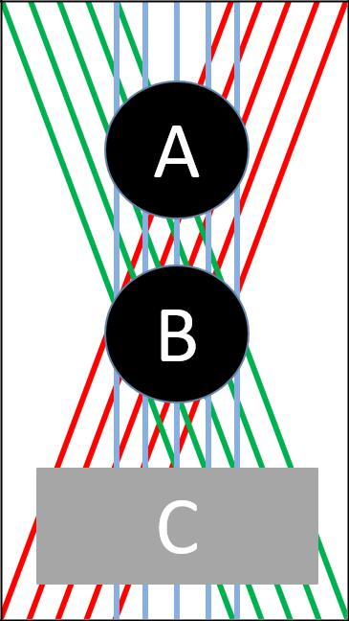

*Figure 5. A diagram illustrating some of the possible paths for muons through at least one of the Geiger****–*** *Müller tubes, circles A and B, as well as the CsI crystal.*



**Arduino Mega and Sensors**

The rest of the payload consists an Arduino Mega microcontroller, a barometer, a thermometer, a GPS unit, and an SD card data logger. The Arduino Mega is an integrated microcontroller unit that will control the sensors and pass the collected information to the data

**logger. The data logger is a micro SD card “shield”, a preassembled board that can be stacked**

directly onto the Mega while still providing access to all the microcontroller**’**s input and output pins. The barometer and thermometer are built onto a single chip and provide additional atmospheric data concerning the payload during the flight. Finally, a GPS unit is used primarily for collecting altitude data.

**Payload Construction**

The basic skeletal structure of the payload was designed several semesters ago by the UNC DemoSat students. The primary goals of the design were that it had to be modular, easy to modify, easy to manufacture, and would prove to be reliable. During the last several high-altitude balloon launches, this design has been used and has met these goals. Because of this, the

8

original design was to be utilized again. Therefore, the major focus of the project, from a structural stand point, was the development of a more advanced payload system for the sensitive instrumentation.

During testing of the electronics, it was found that the high voltage required by the Geiger**–**Müller tubes would cause electrical arcing when exposed to low pressures, like those that occur at high altitude. After several failed attempts to shield the electronics from arcing, the Geiger**–**Müller tubes had to be sealed inside a large PVC pipe to maintain ground level pressure during the flight.

The PVC pipe, while fulfilling its intended purpose, was extremely heavy and a poor use of space inside the frame. From the onset of this flight, the development of a properly sealed vessel for the instruments was a top priority. Utilizing computer aided drafting, and 3D printed ABS plastic, several prototypes were produced and tested. While sounding like a simple and straight forward project, an extensive list of obstacles was encountered. These included; mitigating layer separation of the 3D print, determining the best type of sealants to be used, and identifying assembly techniques that would reduce the possibility of construction errors. A box was designed that was believed to be able to maintain ground pressure. During testing, the design was placed in a vacuum chamber that produced the similar pressures to those encountered at an altitude of approximately 250,000 feet above sea level. During this testing, the box was able to retain an internal pressure to those found at about 6,000 feet above sea level. The box was easily integrated into the existing frame, and the resulting payload mass was significantly reduced over using PVC pipe.

**Balloon Provider**

The payload was launched on a high-altitude helium balloon provided by Edge of Space Sciences (EOSS). In addition to providing the balloon, they attach their own small payload that transmitted live GPS data including latitude, longitude, and altitude.

1. *Results*

For this flight, we were not able to get the scintillation detector to function properly. Therefore, we replaced the scintillator with an equivalent mass and launched the payload with only the two Geiger**–**Müller tubes. In this configuration, a coincidence count was registered

9

when both Geiger**–**Müller tubes were triggered. Figure 6 displays the collected data from the flight in addition to the Palmer model.

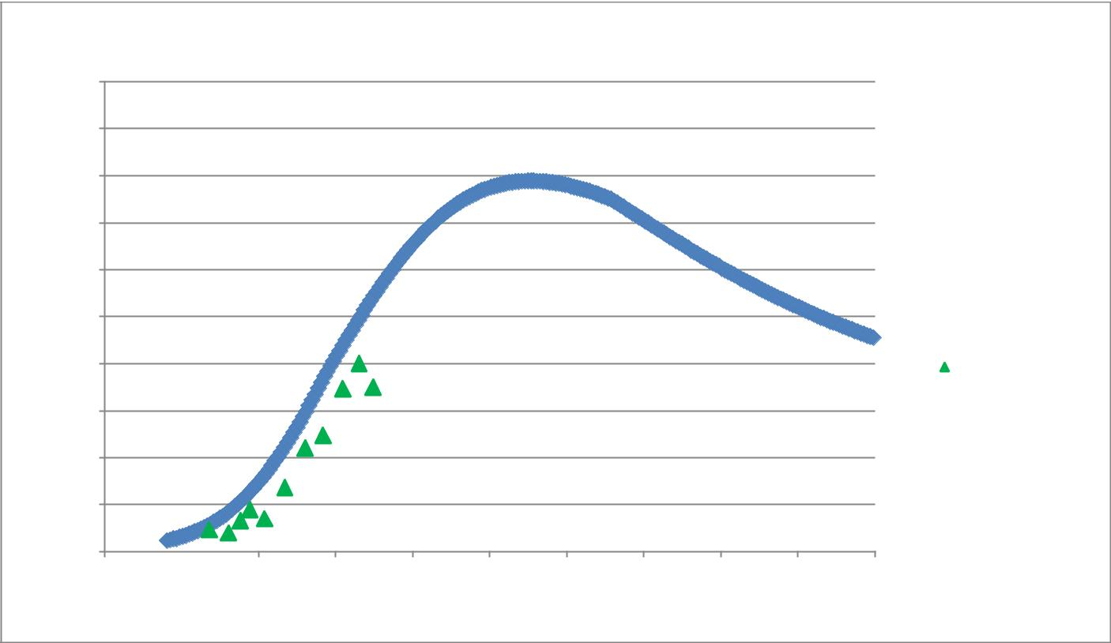

**Palmer Model: Muon Count Rate vs Altitude**

|  |
| --- |
| **Count Rate (cpm)** |

150

135

120

105

90

75

Palmer Model

|  |  |
| --- | --- |
| 60 | Spring 2017 Data |

45

30

15

0 

0 12500 25000 37500 50000 62500 75000 87500 100000 112500 125000

**Altitude (ft)**

*Figure 6. A graph displaying the data from the Spring 2017 DemoSat launch with the predicted count rate from the Palmer model.*

*IV.* *Analysis*

After reviewing the collected data, we found that several pieces of the payload failed to function properly. The GPS unit failed to update all of the information during the flight. Though the GPS unit did not update the altitude information, it did continue to provide good timestamp data. We were able to compare this timestamp with the tracking data received from EOSS. Using this information, we were able to determine the altitude at which the count rate was collected with an uncertainty of ± 20 seconds.

Additionally, the box that was intended to hold the Geiger**–**Müller tubes at ground level pressure failed. A leak developed in the wall of the box and caused the pressure inside to drop. When the pressure dropped to a low enough level, there was an electrical failure that caused the Geiger**–**Müller tubes to go into a safe-operation mode and stop collecting data [see Figure 7]. From previous testing of the tubes in a vacuum chamber, it was found that the Geiger**–**Müller tubes begin to arc when they are exposed to an ambient pressure of approximately 70

10

kilopascals. This pressure corresponds to an altitude of roughly 32,000 feet. The pressure box was able to maintain an ambient pressure above 70 kilopascals until the box reached approximately 45,000 feet. At that time, an electrical fault occurred and the payload stopped collecting data.

|  |  |  |  |
| --- | --- | --- | --- |
|  | Altitude (EOSS) (ft) | Pressure Inside Box (pa) | Estimated Pressure (pa) |
| Ground Level | 4846 | 83703 | 84795 |
| Empirical Arc Altitude | 32421 | 74827 | 70000 |
| Maximum Collected Data | 44291 | 68965 | 15259 |

*Figure 7. A table displaying the actual altitude of the payload, the actual pressure inside of the box, and the estimated pressure outside of the box for the Spring 2017 DemoSat launch.*

Despite the malfunctions of these two components of the payload, they do not affect the integrity of the collected data. The data are still consistent with the Palmer model, as well as the data collected during the Fall 2016 launch.

Additional work is still needed to identify the cause of the pressure failure in the box, determine the reason the GPS unit did not update the altitude, and to complete the construction of the scintillation detector before the upcoming flight during the solar eclipse in August 2017.

1. *Acknowledgments*

As a team, we would like to thank several individuals whose guidance was irreplaceable throughout the course of this experiment. Dr. C Galovich, Dr. C. Kuehn, and Dr. M. Semak, professors at the University of No**rthern Colorado’s Department of Physics and Astronomy,** whose supervision and expertise were invaluable. The volunteers at Edge of Space Sciences, Inc. that facilitated the actual launch of our payload by providing the balloon and continuously tracking its position during the flight for successful recovery. Finally, we would like to thank Chris Koehler, Bernadette Garcia, and the rest of the staff at the Colorado Space Grant Consortium for their guidance and support throughout this project.

11

*VI.* *Works Cited*

1. Hess, V. F., & Anderson, C. D. (1965). Victor F. Hess - Biographical. In *Nobel* *lectures physics 1922-1941: including presentation speeches and laureates' biographies*. Amsterdam: Elsevier. Retrieved fromhttp://www.nobelprize.org/nobel_prizes/physics/laureates/1936/hess-bio.html
2. Mewaldt, R. A. (1996). Cosmic Rays. Retrieved from http://www.srl.caltech.edu/personnel/rmewaldt/cos_encyc.html
3. Ibid.
4. Ibid.
5. Ibid.
6. Zell, H. (Ed.). (2015, July 30). Earth's Atmospheric Layers. Retrieved from https://www.nasa.gov/mission_pages/sunearth/science/atmosphere-layers2.html
7. Mewaldt, R. A. (1996). Cosmic Rays. Retrieved from http://www.srl.caltech.edu/personnel/rmewaldt/cos_encyc.html
8. Nave, C. R. (n.d.). Atmospheric Muons. Retrieved from http://hyperphysics.phy-astr.gsu.edu/hbase/Particles/muonatm.html
9. Brewer, J. H., III, Hansford, N. J., Hill, J. C., Palmer, M. G., & Kuhlman, J. M. (2007). *High Altitude Cosmic Radiation (HACR) Detector Payload Summary and* *Flight Science Report* [Scholarly project]. In *The High Altitude Student Platform*.Retrieved from http://laspace.lsu.edu/hasp/groups/2007/science_report/Payload_08/Flight_Report

.pdf

1. Benson, T. (Ed.). (2014, July 12). Earth Atmosphere Model. Retrieved from https://www.grc.nasa.gov/www/k-12/rocket/atmos.html
2. Brewer, J. H., III, Hansford, N. J., Hill, J. C., Palmer, M. G., & Kuhlman, J. M. (2007). *High Altitude Cosmic Radiation (HACR) Detector Payload Summary and* *Flight Science Report* [Scholarly project]. In *The High Altitude Student Platform*.Retrieved from http://laspace.lsu.edu/hasp/groups/2007/science_report/Payload_08/Flight_Report

.pdf

12

1. The Geiger Counter and Counting Statistics. (1994). Retrieved from http://www.its.caltech.edu/~derose/labs/exp2.html
2. Rex, A. and Thornton, S. (2013). *Modern Physics for Scientists and Engineers, 4th* *Edition*. Cengage Learning,
3. Scintillation Detectors. (N.d.). Radiation Sciences, McMaster University, Ontario. Retrieved from https://www.science.mcmaster.ca/radgrad/images/6R06CourseResources/4R6Not es4_ScintillationDetectors.pdf

13

*VII. Appendices*

**Appendix 1: Parts and Price List**

|  |  |  |  |  |  |  |  |
| --- | --- | --- | --- | --- | --- | --- | --- |
| **Component** |  | **Price (ea)** | **Mass (ea)** | **Quantity** | **Price** |  | **Mass** |
|  |  |  |  |  |  |  |  |
| Arduino Mega |  | $49.95 | 36 g | 1 | $49.95 |  | 36 g |
|  |  |  |  |  |  |  |  |
| SD Card Shield |  | $14.95 | 17 g | 1 | $14.95 |  | 17 g |
|  |  |  |  |  |  |  |  |
| Sparkfun Geiger Counter |  | $149.95 | 59 g | 2 | $299.90 |  | 118 g |
|  |  |  |  |  |  |  |  |
| Scintillator Crystal |  | $128.00 | 42 g | 1 | $128.00 |  | 42 g |
|  |  |  |  |  |  |  |  |
| Silicon Photomultiplier |  | $132.00 | 1 g | 1 | $132.00 |  | 1 g |
|  |  |  |  |  |  |  |  |
| Li-ion Battery |  | $9.95 | 42 g | 2 | $19.90 |  | 84 g |
|  |  |  |  |  |  |  |  |
| Li-ion Battery Charger |  | $7.95 | 3 g | 2 | $15.90 |  | 6 g |
|  |  |  |  |  |  |  |  |
| GPS Unit |  | $49.95 | 15 g | 1 | $49.95 |  | 15 g |
|  |  |  |  |  |  |  |  |
| Pressure and Temperature Sensor |  | $14.95 | 5 g | 1 | $14.95 |  | 5 g |
|  |  |  |  |  |  |  |  |
| Heater Element |  | $3.50 | 5 g | 1 | $3.50 |  | 5 g |
|  |  |  |  |  |  |  |  |
| Toggle Switch |  | $3.72 | 8 g | 2 | $7.44 |  | 16 g |
|  |  |  |  |  |  |  |  |
| Lead |  | na | 68 g | 2 | na |  | 136 g |
|  |  |  |  |  |  |  |  |
| 3D Printed Structure |  | na | na | na | na |  | 476 g |
|  |  |  |  |  |  |  |  |
| Thermal Shielding |  | na | na | na | na |  | 252 g |
|  |  |  |  |  |  |  |  |
|  | **Total** | |  |  | **$543.54** |  | **1156 g** |
|  |  |  |  |  |  |  |  |

14

**Appendix 2: Payload Images**

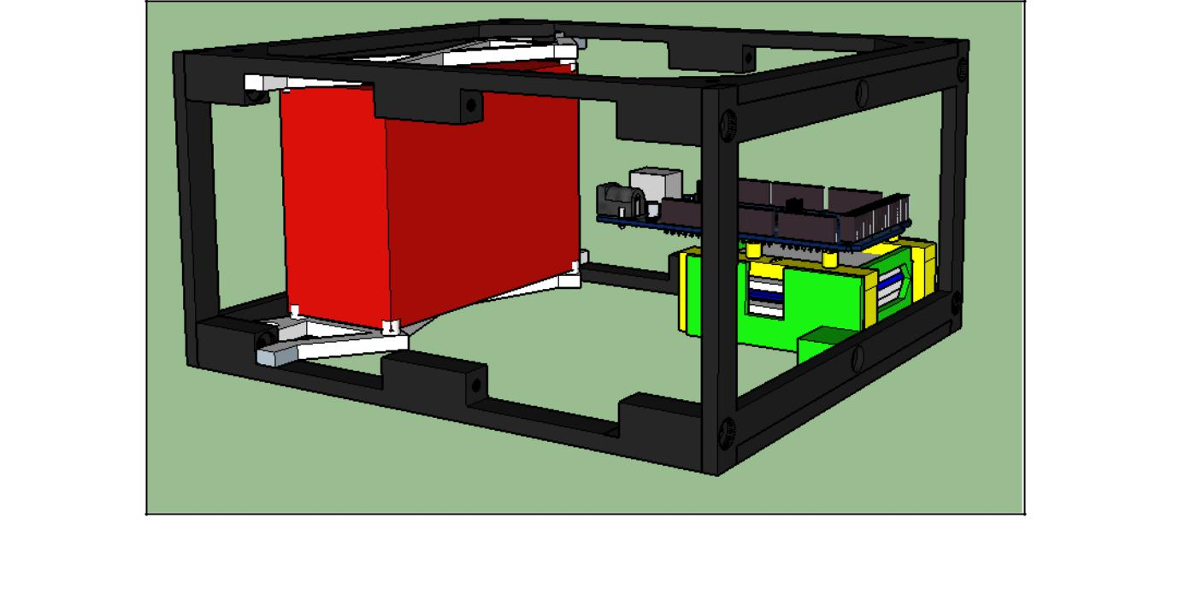

*A 3D rendering of the payload. The red box is the pressure container that holds the Geiger-Muller tubes and scintillation detector. The green structure holds li-ion batteries to power the payload. Sitting on top of the battery box is the Arduino Mega.*

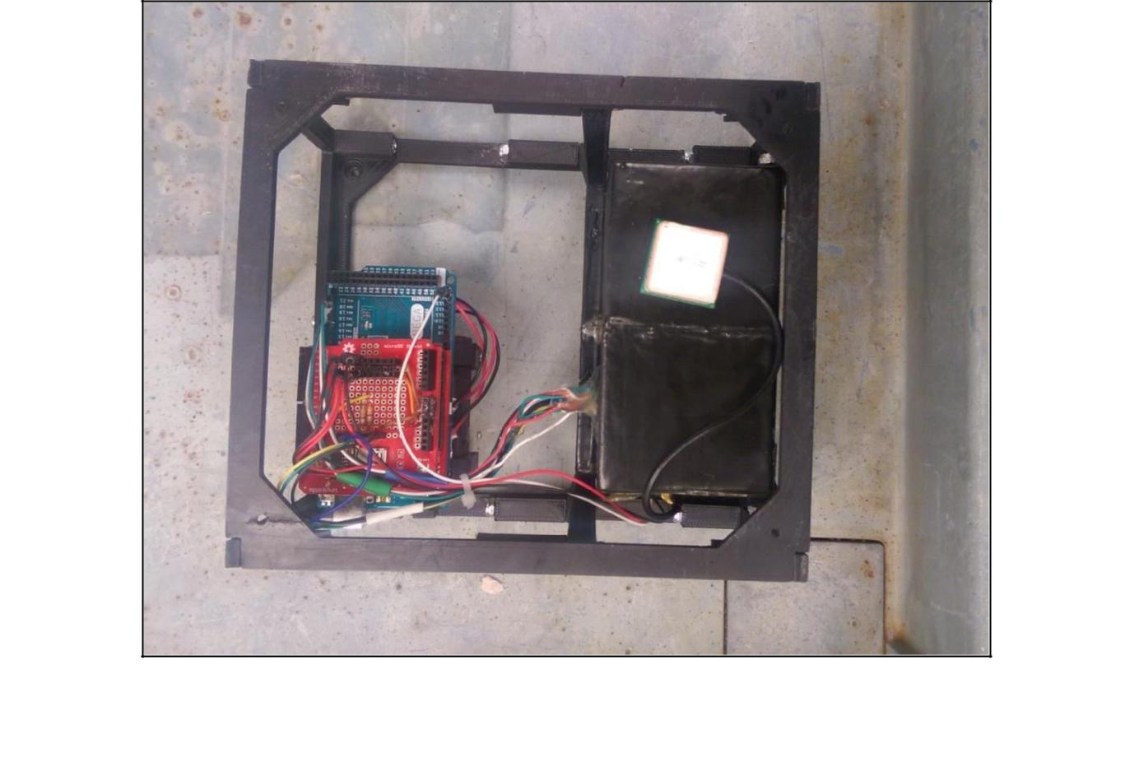

*Above is a picture of the top of the completed payload before it is wrapped in thermal insulation. The white square is the GPS antenna. Below it is the pressure box. The red board is the micro SD card shield attached to the top of the Arduino Mega.*

15

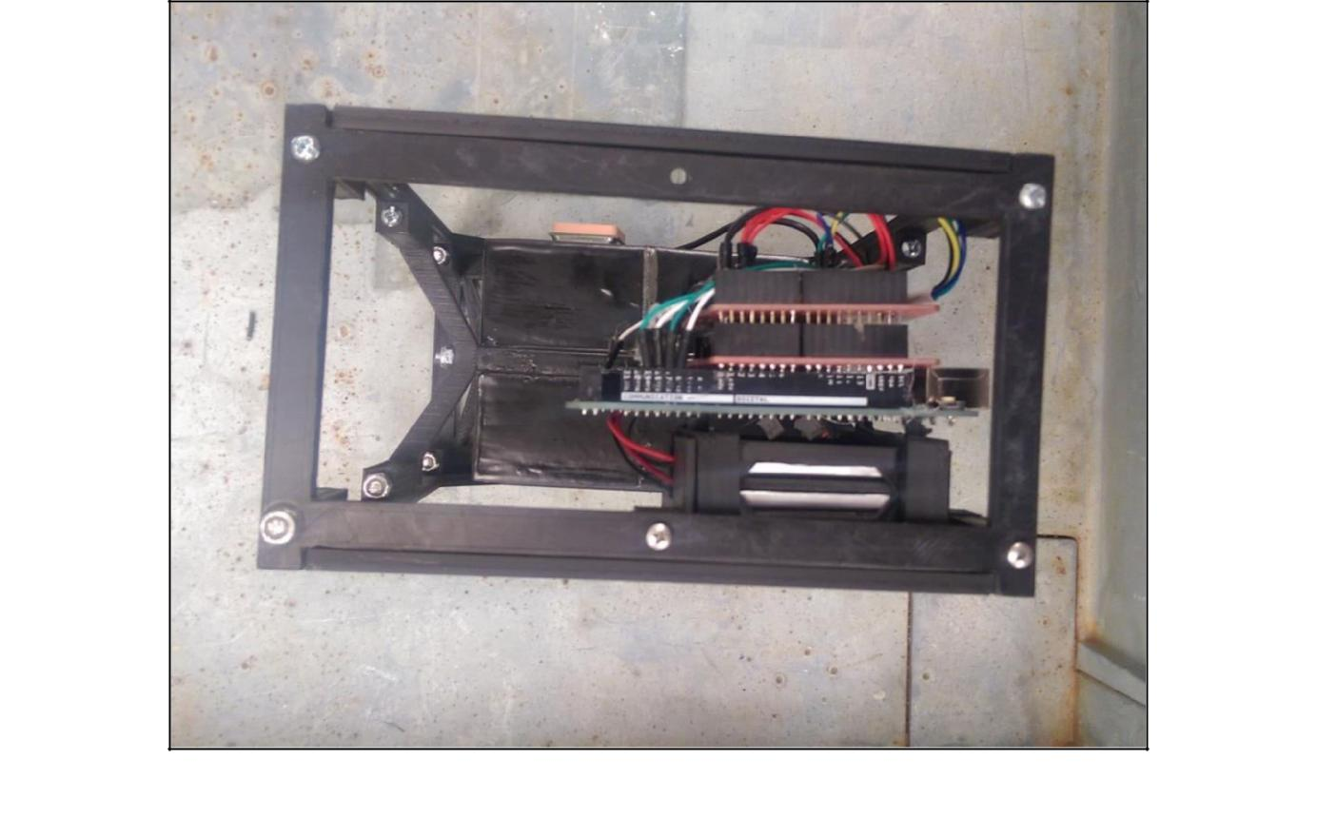

*Above is a picture of the side of the completed payload before it is wrapped in thermal insulation.*

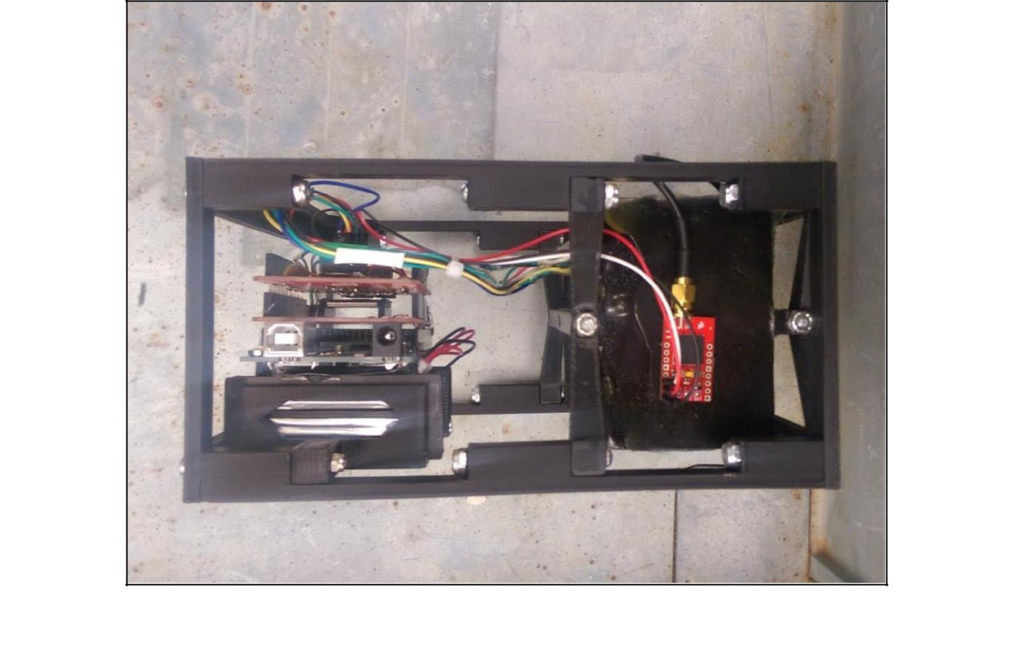

*Above is a picture of the front of the completed payload before it is wrapped in thermal insulation. The red rectangular board on the right side of the picture is the GPS unit.*

16

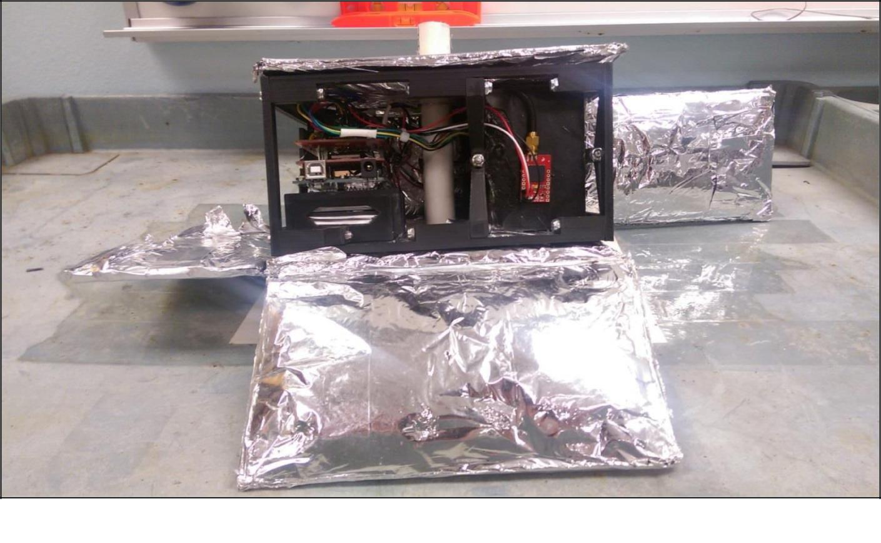

*Above is a picture of the front of the completed payload as it is being wrapped in thermal insulation.*

17

**Appendix 3: Arduino Code**

//Libraries

#include <SPI.h>

#include <Wire.h>

#include <SD.h>

#include <SoftwareSerial.h>

#include "SparkFunMPL3115A2.h"

//LED pins

int rled = 6;

int gled = 7;

//Setup pressure sensor

MPL3115A2 myPressure;

//Setup GPS

SoftwareSerial gpsSerial(69, 68); //(RX, TX)

const int sentenceSize = 80;

char sentence[sentenceSize];

//Counter variables

int timer;

int start;

int check_A;

int check_B;

unsigned long count_A;

unsigned long count_B;

unsigned long Total;

//Keep track of elapsed time

unsigned long timeStamp;

//Setup SD sheild

const int chipSelect = 8;

void setup()

{

//RX & TX ports

Serial.begin(9600); //xBee

Serial1.begin(9600); //Giger Counter 1

Serial2.begin(9600); //Giger Counter 1

Serial3.begin(9600); //Scintilator

gpsSerial.begin(9600); //GPS

//SDA & SCL ports

Wire.begin();

//Configure pressure sensor

myPressure.begin();

myPressure.setModeBarometer();

myPressure.setOversampleRate(128);

myPressure.enableEventFlags();

//Configure LED pins

pinMode(rled, OUTPUT);

pinMode(gled, OUTPUT);

//Configure SD sheild

pinMode(chipSelect, OUTPUT);

delay(50);

Serial.print("Initializing SD card...");

delay(500);

//Check for an SD card

if (!SD.begin(10, 11, 12, 13))

{

Serial.println("Card failed, or not present");

delay(1000);

return;

}

Serial.println("card initialized.");

digitalWrite(rled, HIGH);

delay(1000);

}

18

void loop()

{

static int i = 0;

if (gpsSerial.available())

{

char ch = gpsSerial.read();

if (ch != '\n' && i < sentenceSize)

{

sentence[i] = ch;

i++;

}

else

{

sentence[i] = '\0';

i = 0;

{

char field[20];

getField(field, 0);

String dataString = "";

if (strcmp(field, "$GPGGA") == 0)

//This is where all of the data colection needs to go

{

//Indicate that the payload is collecting data

{

digitalWrite(gled, HIGH);

}

//Timestamp

{

timeStamp = millis();

dataString += String(timeStamp);

dataString += ", ";

}

//GPS data

{

//Time

getField(field, 1);

dataString += String(field);

dataString += ", ";

//Latitude

getField(field, 2);

dataString += String(field);

dataString += ", ";

//Longitude

getField(field, 4);

dataString += String(field);

dataString += ", ";

//Altitude

getField(field, 9);

dataString += String(field);

dataString += ", ";

}

//Temperature and Pressure

{

//Pressure

float pressure = myPressure.readPressure();

dataString += String(pressure, 2);

dataString += ", ";

//Temperature

float temperature = myPressure.readTempF();

dataString += String(temperature, 2);

dataString += ", ";

}

//Giger Counters

{

//Configure counter

start = millis();

timer = start;

count_A = 0;

count_B = 0;

19

Total = 0;

//Counter

while ((timer-start) <= 30000)

{

//Geiger Counter readers

check_A = Serial1.read();

check_B = Serial2.read();

//Coincidence logic

if (check_A > 0)

{

count_A++;

}

if (check_B > 0)

{

count_B++;

}

if (check_A > 0 && check_B > 0)

{

Total++;

}

timer = millis();

}

//Convert counts to CPM

count_A = count_A*2;

count_B = count_B*2;

Total = Total*2;

dataString += String(count_A);

dataString += ", ";

dataString += String(count_B);

dataString += ", ";

dataString += String(Total);

dataString += ", ";

}

//Print to SD card

{

File dataFile = SD.open("datalog.txt", FILE_WRITE);

if (dataFile)

{

Serial.println(dataString);

dataFile.println(dataString);

dataFile.close();

}

else

{

Serial.println("error opening datalog.txt");

Serial.println(dataString);

digitalWrite(rled, LOW);

delay(250);

digitalWrite(rled, HIGH);

delay(250);

digitalWrite(rled, LOW);

}

}

//Indicate the end of the data run

{

digitalWrite(gled, LOW);

delay (250);

}

}

}

}

}

}

//This section helps to parse the GPS data retreive usable peices void getField(char* buffer, int index) {

int sentencePos = 0;

int fieldPos = 0;

20

int commaCount = 0;

while (sentencePos < sentenceSize)

{

if (sentence[sentencePos] == ',')

{

commaCount ++;

sentencePos ++;

}

if (commaCount == index)

{

buffer[fieldPos] = sentence[sentencePos];

fieldPos ++;

}

sentencePos ++;

}

buffer[fieldPos] = '\0';

}

21